



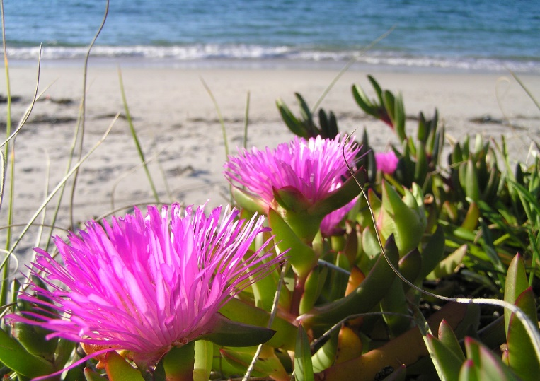**2nd Quarterly Newsletter April-June 2022**

Hello Southpoint Owners,

Happy Springtime! I hope you are all enjoying the warmer weather that is upon us, for no matter how long the winter, Spring is sure to follow.

SPC building updates:

The new LED outdoor light fixtures for above all doorways have been installed and they make a big difference. They are a lower profile style, a bit brighter and whiter, and will be much more energy efficient. I took these pictures of the building in April.

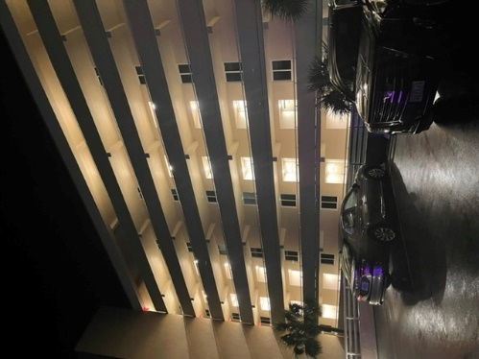 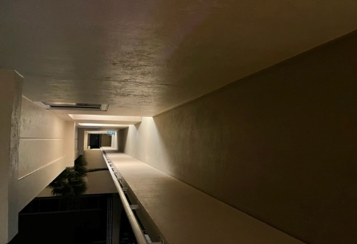



There were many of these on the beach in the last couple of weeks… stay away from them!

The Portuguese man o’ war is a predatory species. It uses its feeding tentacles to sting and paralyze small fishes, pelagic crustaceans, and other invertebrates. The feeding tentacles may be up to 160 feet long in some individuals! These tentacles deliver a powerful sting and are also used for defense against predation. Few species eat the Portuguese man o’ war, but some predators that specialize on stinging, gelatinous invertebrates (e.g., [loggerhead sea turtles](https://oceana.org/marine-life/sea-turtles-reptiles/loggerhead-turtle) and [ocean sunfish](https://oceana.org/marine-life/ocean-fishes/ocean-sunfish)) are known to feed on this and other siphonophores.

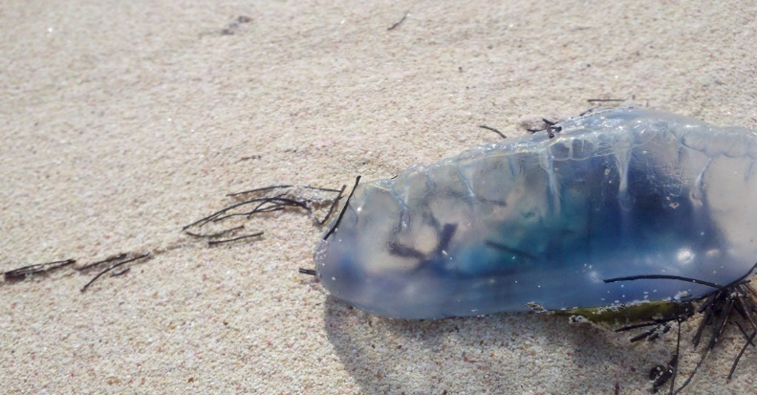

# Fun Facts About the Portuguese Man o’ War

**1.** The Portuguese man o’ war is not a jellyfish, but rather a siphonophore, which is a colony of specialized animals called zooids that work together as one. **2.** The Portuguese man o’ war doesn’t swim. Instead, it uses wind and ocean currents to propel it forward. **3.** The Portuguese man o’ war was named after its resemblance to 18th century Portuguese warships.**4.** The Portuguese man o war’s float can be up to 6 inches (15 cm) tall. **5.**The Portuguese man o’ war’s tentacles grow as long as 165 feet. Yikes! Pretty to look at but don’t touch them!!

**Southpoint Owner's Email List**

About 8 years ago, a private, online group for Southpoint owners was started to stay in touch with each other. It’s been used to communicate during hurricanes, discuss HOA changes, and stay updated on building construction, and more. Currently about 50 owners are in the Google group mailing list. Any owner can use it to send a message/question/comment to all the other owners. This e-mail list was recently used to send out a recap of the HOA meeting in Dec. If you would like to be added, send an email to fellow owner Kevin David (k.david@gtoast.net) who manages the group.



I’m looking for owners to be in the spotlight. Don’t be shy! If interested, please send me a short bio, pictures and e-mail to me. Thank you!

Thank you for your suggestions and comments given to me for our newsletter. Please feel free to continue to send pictures and content to me. Thank you!

Respectfully,

Linda Collette, [redcar@charter.net](mailto:redcar@charter.net)

**Southpoint Board Members**

Phil Danley, President

Linda Collette, Vice President

Judy Voiers, Secretary/Treasurer

**Southpoint Rental Board Members**

Alan Powell, President

Judy Voiers, Vice President

Linda Collette, Secretary

Management Company: TJW Management Co, Inc.

Roger Koop, Manager and Maintenance Supervisor, 386-788-4546--[roger.koop@gmail.com](mailto:roger.koop@gmail.com) Karen Stewart - General Manager- kstewart@tjw.net